**OOPS CPP DSA0163**

**PRE MODEL EXAM**

**QUESTION 1:**

**CODE:**

**#include<iostream>**

**using namespace std;**

**class Rectangle{**

**private:**

**int l,b;**

**public:**

**int area,perimeter;**

**void get(){**

**cout<<"Enter the Length:"<<endl;**

**cout<<"Enter the Breadth:";**

**cin>>l;**

**cin>>b;**

**area=l*b;**

**perimeter = 2*(l+b);**

**}**

**void display(){**

**cout<<"Area of rectangle:"<<area<<endl;**

**cout<<"Perimeter of rectangle:"<<perimeter<<endl;**

**}**

**};**

**int main(){**

**Rectangle r;**

**r.get();**

**r.display();**

**}**

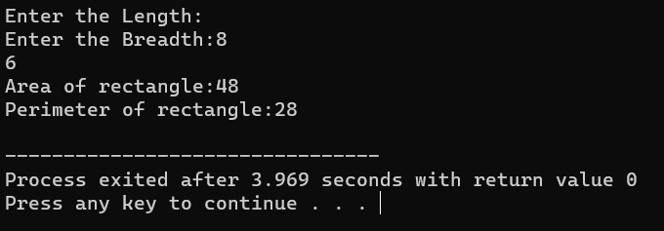

**QUESTION 2:**

**CODE:**

**#include<iostream>**

**using namespace std;**

**class Piggybank**

**{**

**public:**

**int amount=50;**

**int amt,A;**

**Piggybank(){**

**cout<<"Enter amount:";**

**cin>>amt;**

**}**

**void display(){**

**cout<<"No Amount will be added to the Piggybank."<<endl;**

**}**

**Piggybank1(){**

**cout<<"Update in Amount:";**

**cin>>amt;**

**A=amt+amount;**

**cout<<A;**

**}**

**void display1(){**

**cout<<A <<"is Updated Amount ";**

**}**

**};**

**int main(){**

**Piggybank p;**

**p.display();**

**p.display1();**

**}**

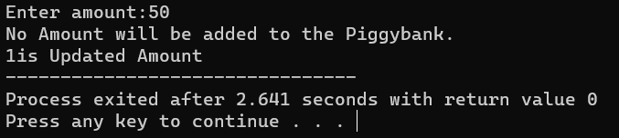

**QUESTION 3:**

**CODE:**

**#include<iostream>**

**using namespace std;**

**class Vehical**

**{**

**public:**

**string make,model;**

**int year;**

**void set(){**

**cout<<" Enter make :";**

**cin>>make;**

**cout<<"Enter model :";**

**cin>>model;**

**cout<<"Enter year :";**

**cin>>year;**

**}**

**void display(){**

**cout<<make<<endl<<model<<endl<<year<<endl;**

**}**

**};**

**class Car:public Vehical{**

**public:**

**int no_passenger;**

**string color;**

**void get(){**

**cout<<"Enter no_passenger :";**

**cin>>no_passenger;**

**cout<<"Enter color :";**

**cin>>color;**

**}**

**void dis(){**

**cout<<no_passenger<<endl<<color;**

**}**

**};**

**int main(){**

**Car c;**

**c.set();**

**c.display();**

**c.get();**

**c.dis();**

**}**

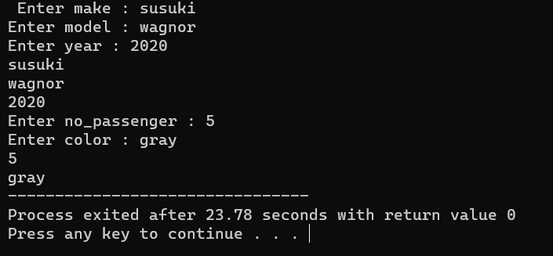

**QUESTION 4:**

**CODE:**

**#include<iostream>**

**using namespace std;**

**int main()**

**{**

**int i, space, k=0;**

**for(i=1; i<=3; i++)**

**{**

**for(space=1; space<=(3-i); space++)**

**cout<<" ";**

**while(k!=(2*i-1))**

**{**

**cout<<"1 ";**

**k++;**

**}**

**k=0;**

**cout<<endl;**

**}**

**cout<<endl;**

**return 0;**

**}**

